Fontana Conference Room Booking

In the Outlook App
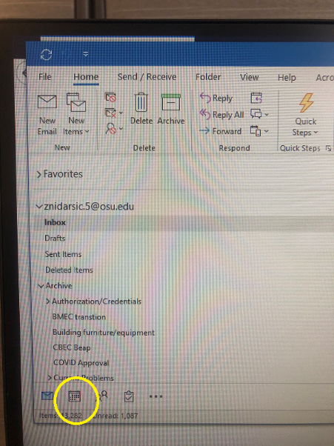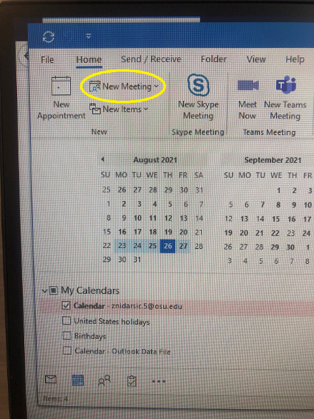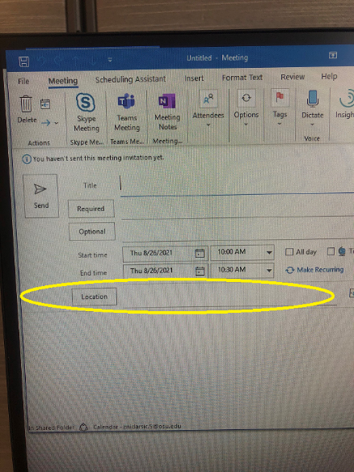
- Open Create a Meeting
- Under ‘room or location’ search for BMEC Conference rooms
- Click location button

Available room addresses:
+ENG BMEC-Rm-2000
+ENG BMEC-3021-Conf-Room
+ENG BMEC-4021-Conf-Room
+ENG BMEC-2126-Conf-Room
+ENG BMEC-2118-Conf-Room
+ENG BMEC-2130-Conf-Room

In the Outlook Website
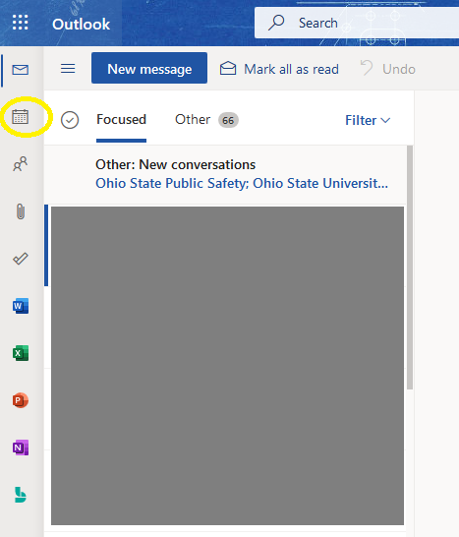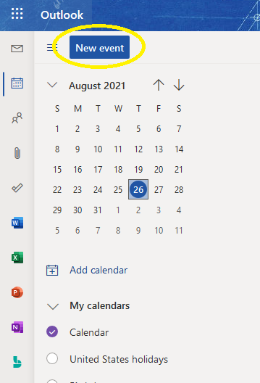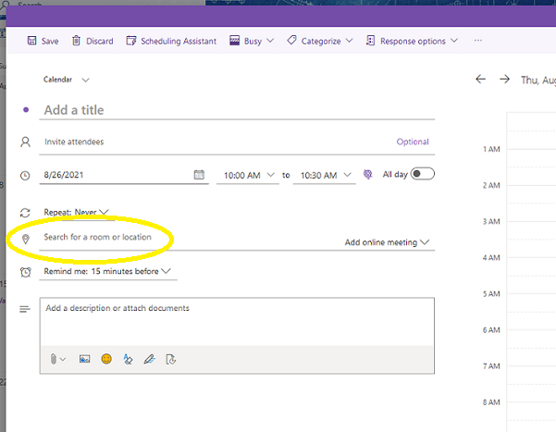
- Select Calendar icon
- Click on New Event
- Search or type room address in the Location field

